**Rendering in simple terms**

In simple terms rendering is all focused on one simple question

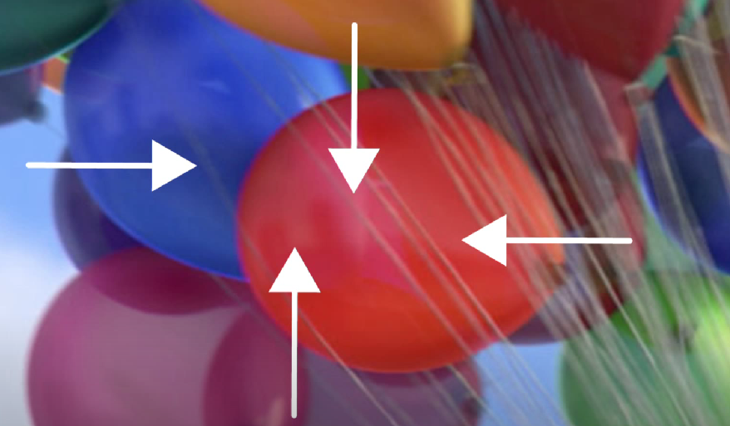

What color is this pixel, and this pixel and this pixel?

All 3D models are made from either triangles or squares ( quads ) like this

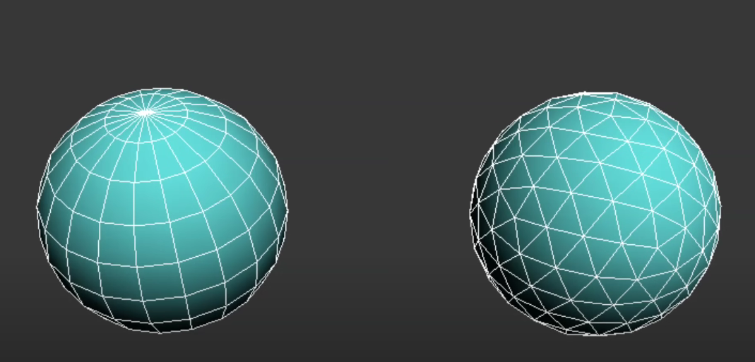

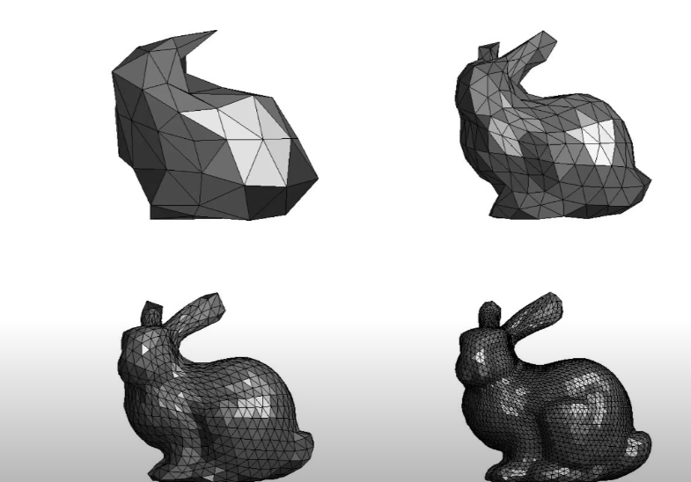

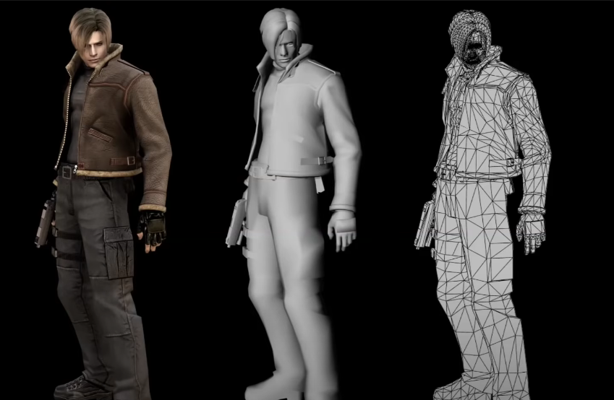

The code we run in the CPU determines what we want to draw and then we send those instructions over to the GPU which will actually figure out the actual pixel colors.

To do this we need a language for communicating between the CPU and GPU, and the most common one is called Open Graphics Language OpenGL

The CPU uses the OpenGL to tell the GPU what to draw. Then the GPU builds up the actual array of colors and ships it to the electronics that run the screen

Ray tracing

It is one of the most versatile and elegant rendering algorithm

Rasterization

Just like ray tracing this is also one of the rendering method

